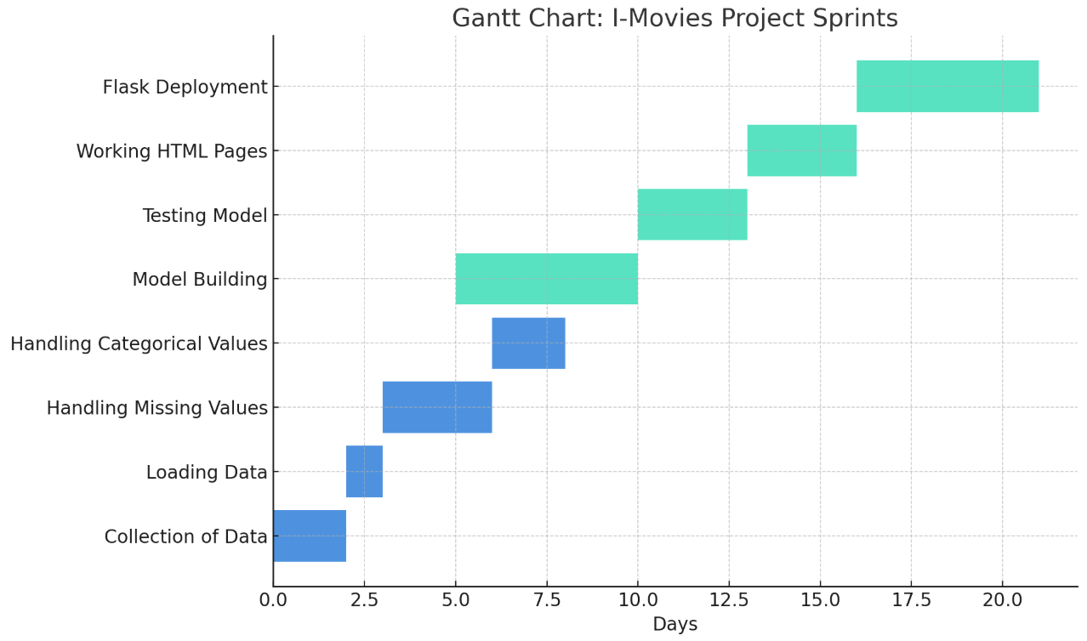
Here is the Gantt Chart for I-Movies Project Planning Logic – it visually maps out your two sprints, their epics, tasks (stories), and the estimated effort in Story Points (duration in days).

Agile Planning Summary

Key Concepts
- Epic: Larger goal (e.g., Data Collection, Model Building)
- Story: Small task within an epic (e.g., Collection of Data)
- Story Point: Effort estimate (based on complexity) using numbers like Fibonacci (1, 2, 3, 5, etc.)
- Sprint: Time-boxed work period (here, 5 days)

Sprint Breakdown

Sprint 1 (5 Days):
Epic 1: Data Collection
- Collection of Data – 2 Story Points (Moderate)
- Loading Data – 1 Story Point (Very Easy)
Epic 2: Data Preprocessing
- Handling Missing Values – 3 Story Points (Moderate)
- Handling Categorical Values – 2 Story Points (Easy)
Total: 8 Story Points

Sprint 2 (5 Days):
Epic 3: Model Building
- Model Building – 5 Story Points (Difficult)
- Testing Model – 3 Story Points (Moderate)
Epic 4: Deployment
- Working HTML Pages – 3 Story Points (Moderate)
- Flask Deployment – 5 Story Points (Difficult)
Total: 16 Story Points

Velocity Calculation

Team Velocity: 12 Story Points/Sprint

